

Online Pet Store

Software Requirements Specification

Name: Pavan Sai. Velpumadugu
Reg.No:12219172

Prepared for
Continuous Assessment 3
Spring 2024

1. Introduction
This Software Requirements Specification (SRS) document is intended to clearly define the prerequisites for creating an online pet store application. The document will detail both the functional and non-functional requirements, as well as any constraints and assumptions that should be considered during the development process. This information will ensure that the online pet store meets the desired functionality and user experience.

The Online Pet Store is a proposed system that aims to provide a user-friendly platform for pet owners to browse and purchase pet-related products and services online. The system will automate each and every activity of the manual system, providing quick and accurate information to users. The system will also have a user-friendly interface, making it easy for users to navigate and make transactions.

1.1 Purpose
This document seeks to specify the functional and non-functional requirements, constraints, and assumptions that are integral to the development of the online pet store.

1.2 Scope

The online pet store application aims to provide a platform for users to purchase pet products, accessories, and services online. The application will offer a wide range of pet-related items, including food, toys, grooming products, and healthcare supplies. Additionally, the application will provide features for pet adoption, booking grooming appointments, and accessing educational resources related to pet care.

1.3 Definitions, Acronyms, and Abbreviations

OPS: Online Pet Store
OSS: Online Shopping System

1.4 References
https://supertails.com/

https://www.zigly.com/

https://getbootstrap.com/

1.5 Overview

This document outlines the functional and non-functional requirements, constraints, and assumptions associated with the development of the online pet store application.

2. General Description

The Online Shopping system (OSS) application enables vendors to set up online shops, customers to browse through the shops, and a system administrator to approve and reject requests for new shops and maintain lists of shop categories. Also the developer is designing an online shopping site to manage the items in the shop and also help customers to purchase them online without visiting the shop physically. The online shopping system will use the internet as the sole method for selling goods to its consumers.

2.1 Product Perspective

This product aimed toward a person who don't want to visit the shop as he might don't get time for that or might not interested in visiting there and dealing with lot of formalities.

2.2 Product Functions

User Authentication and Authorization
- Product Management
- Shopping Cart and Wishlist
- Order Management
- Appointment Booking

2.3 User Characteristics

User should be familiar with the terms like login, register, order system, Booking Appointment for Doctor.

2.4 General Constraints
Internet: A full internet connection required.
Operating System: software does not require any specific Operating system

2.5 Assumptions and Dependencies
It is assumed that the hardware designed will work correctly with the third-party operating system and the developed software.
The customer has a computer with Chrome, Microsoft Edge, safari or some other browser and have Internet.

3. Specific Requirements

Various interfaces for the product could be

Login Page

Registration Form

There will be a screen displaying information about product that the shop having.

If the customers, select the buy button then another screen of shopping cart will be opened.
- Customers can book Appointment of doctor.

3.1 External Interface Requirements

3.1.1 User Interfaces
The Pet Store user interface has been specifically designed with their customers in mind, allows to customer to buy pet food and pet accessories without going to shop.
The home screen offers a menu with a list of functions that the device performs. The user can select one of the options on the menu and is taken to the respective screen.

3.1.2 Hardware Interfaces
Hardware requirements for insurance on internet will be same for both parties which are as follows:
Processor: Dual Core
RAM: 2 GB
NIC: For each party

3.1.3 Software Interfaces
that is compatible with Windows, Linux & Mac operating systems.
Software is web based so software needs a web browser and internet connection.

3.1.4 Communications Interfaces
Users can connect with system using browser and internet once user login user can easily buy pet food and pet accessories and book appointment for doctor.

3.2 Functional Requirements
This section provides requirements overview of the system.

3.2.1 Registration

If customer wants to buy the product then he/she must be registered, unregistered user can't go to the shopping cart.

3.2.2 Login

Customer login to the system by entering valid user id and password for the shopping.

3.2.3 Product Management

- Users shall be able to browse products by category, search for specific items, and view detailed product information.

- The system shall provide recommendations based on user preferences and browsing history.

3.2.4 Shopping cart and Wishlist

- Users shall be able to add products to their shopping cart and proceed to checkout.
- The system shall calculate the total cost of the order, including taxes and shipping fees.
- Users shall have the option to apply discount codes or promotional offers during checkout.

3.2.5 Appointment Booking

- Users shall be able to add products to their shopping cart and proceed to checkout.
- The system shall calculate the total cost of the order, including taxes and shipping fees.

3.5 Non-Functional Requirements
Following Non-Functional Requirements will be there in the insurance to the internet:

3.5.1 Performance
- The system shall be able to handle a large number of concurrent users without significant performance degradation.
- Response times for key actions such as product browsing, checkout, and order processing shall be kept within acceptable limits.

3.5.2 Reliability
- The system shall have a backup and recovery mechanism in place to ensure data integrity and availability.
- Scheduled maintenance activities shall be communicated to users in advance to minimize disruption.

3.5.3 Security
- User passwords shall be stored securely using encryption techniques.
- The system shall implement measures to prevent unauthorized access, such as session management and role-based access control.
- Payment processing shall be conducted using secure and compliant methods to protect sensitive financial information.

3.5.4 Usability
- The user interface shall be intuitive and user-friendly, with clear navigation and consistent design elements.
- The application shall be accessible from a variety of devices and screen sizes, including desktops, tablets, and smartphones.

3.7 Design Constraints
The application shall be developed using the following technologies:
- Frontend: HTML, CSS, JavaScript, React.js
- Backend: Node.js, Express.js, MongoDB

4. Analysis Models

Data Flow Diagrams (DFD)
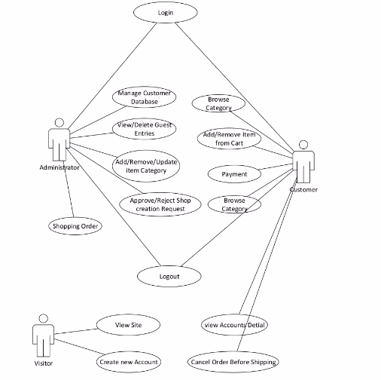

- User Manuals

How we can save our time? How we can search those garments which are difficult to search in the market? These all problems can be easily done through Pet store.

  - Home page

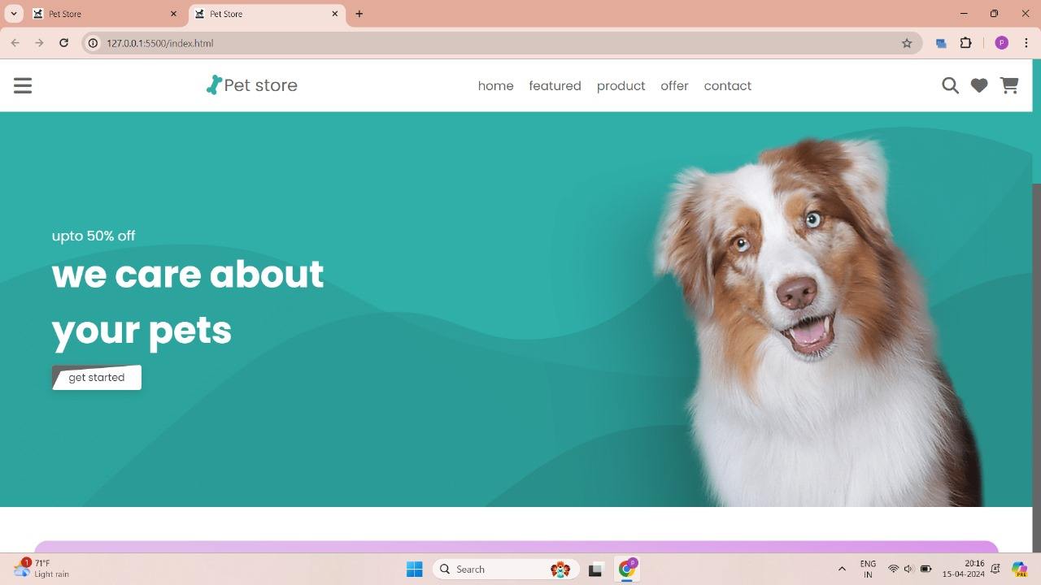

  - Register
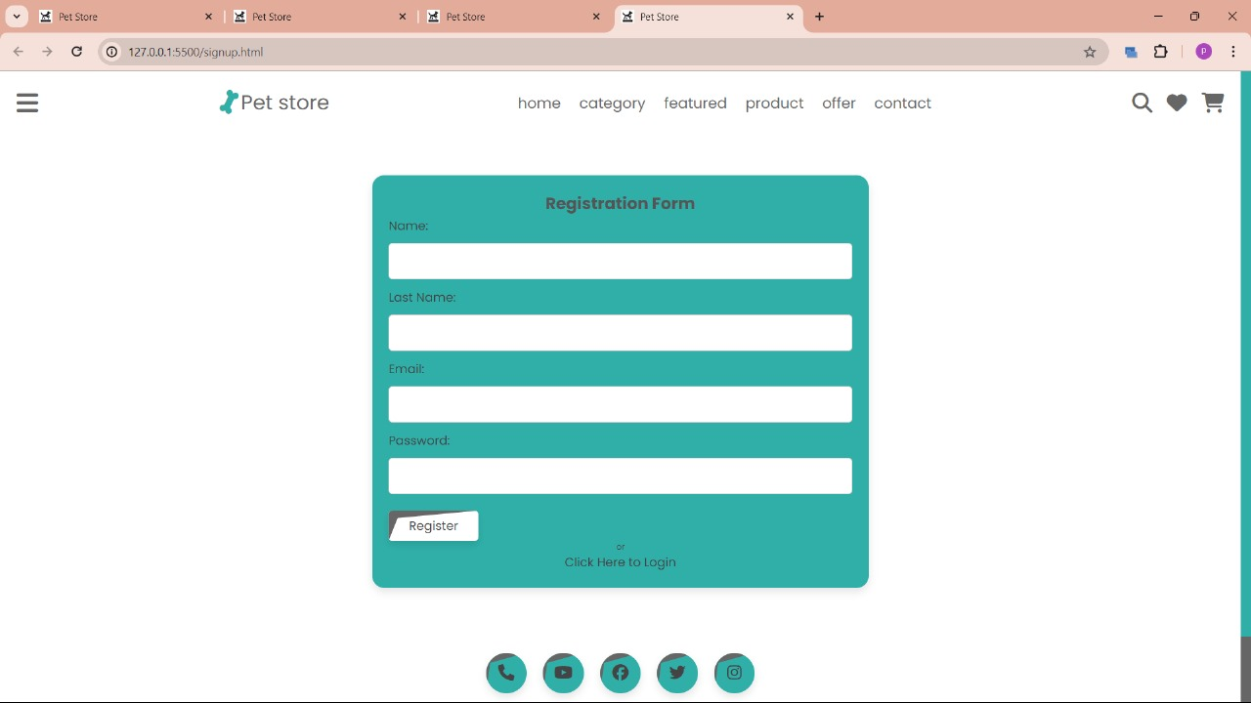
  - Login
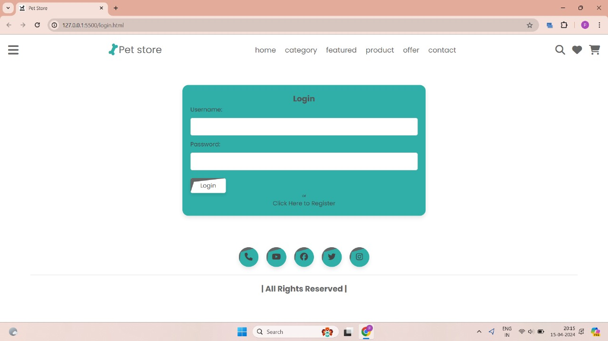
  - Offer page

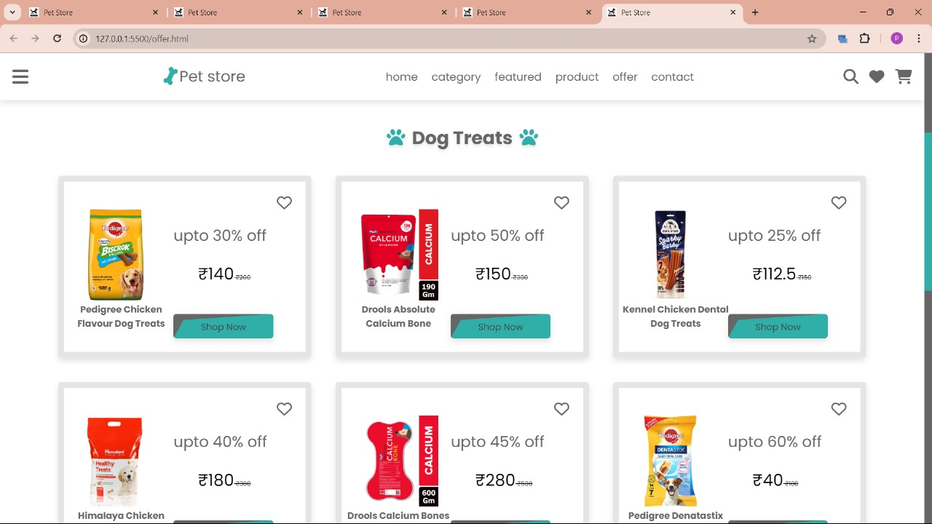

6.5 Product page

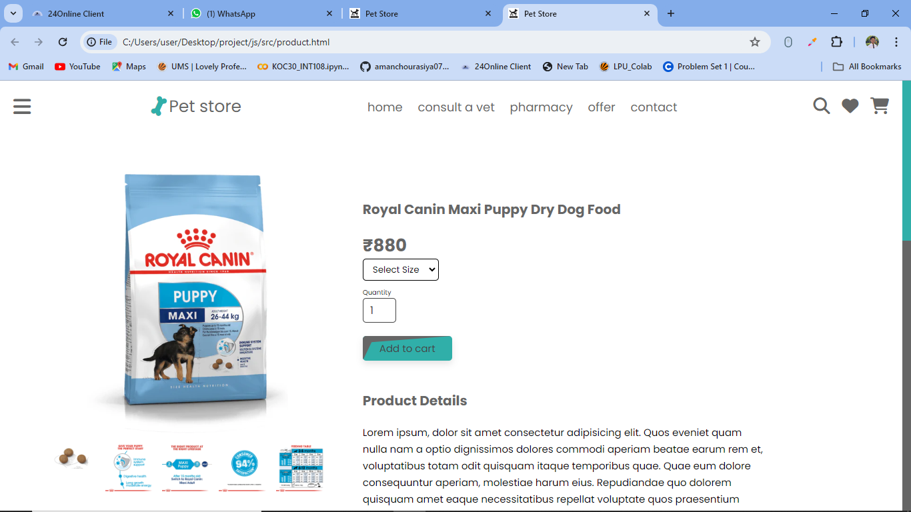

6.6 Cart page

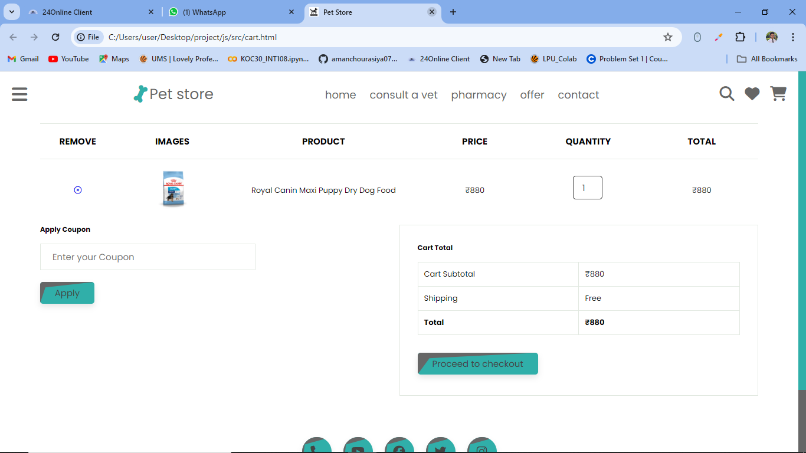

6.7 Order Success page
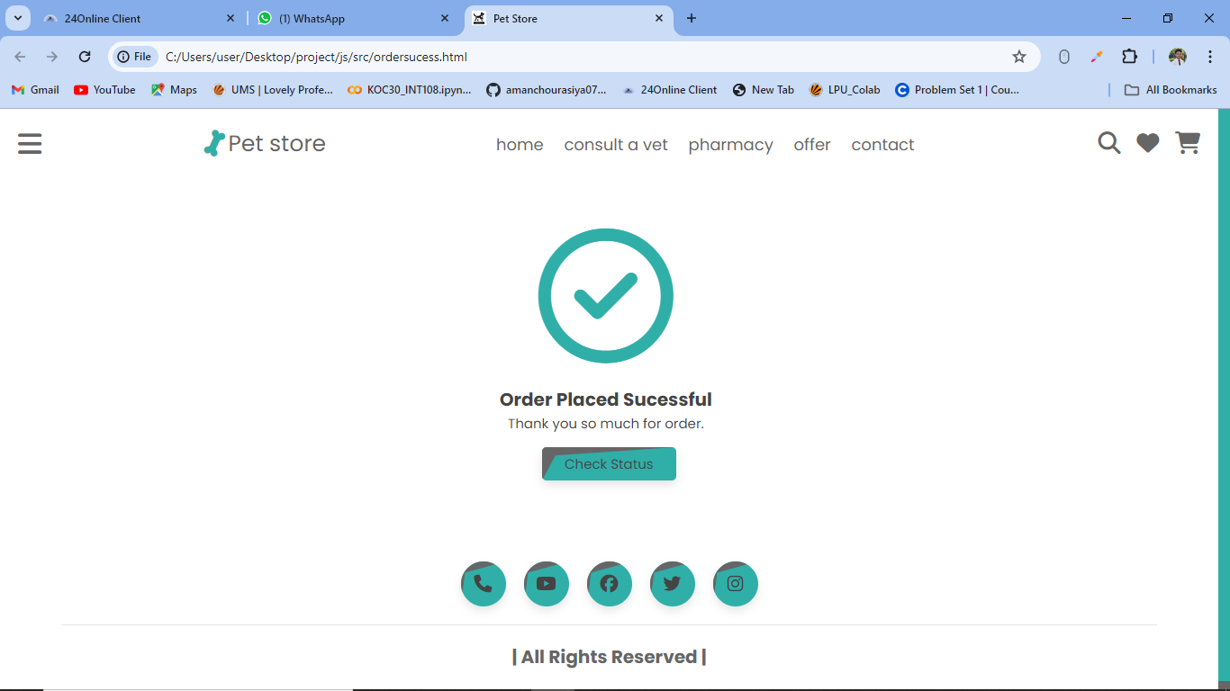

6.8 Contact us

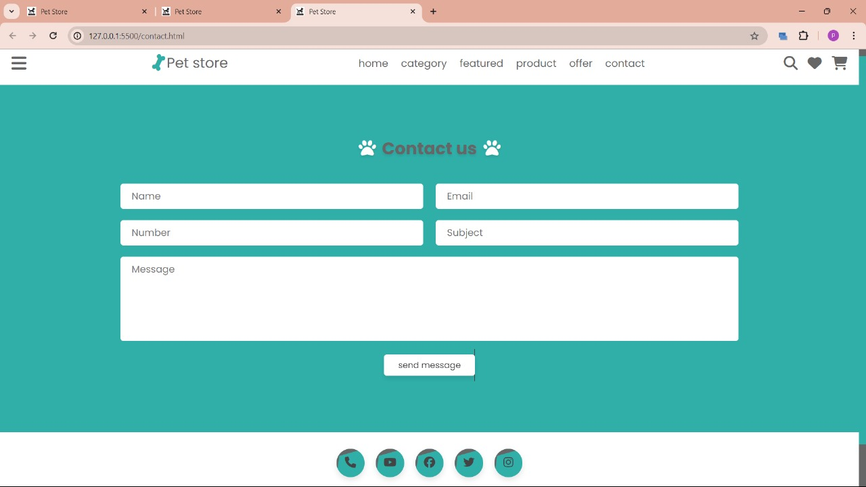

- Conclusion

This Software Requirements Specification (SRS) document outlines the requirements for the development of an online pet store application. By adhering to these requirements, the development team can ensure that the final product meets the needs of both users and administrators while maintaining high standards of performance, security, and usability.

Git Hub Link
https://github.com/pavansai2205/petStore-Project.git

